Simple explanation regarding K-means Clustering in Unsupervised Learning and simple practice with sklearn in python

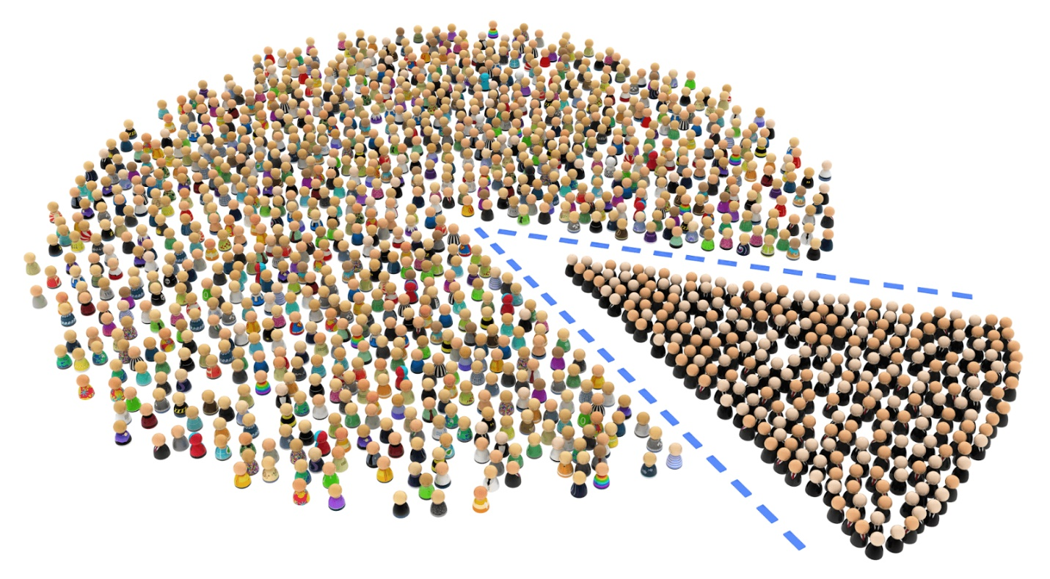

source : [How to Use Customer Segmentation in Google Analytics to Build Your Buyer Personal](https://medium.com/analytics-for-humans/how-to-use-customer-segmentation-in-google-analytics-to-build-your-buyer-persona-8b464e130336)

Previous article :

[**Machine Learning Explanation : Supervised Learning & Unsupervised Learning**](https://medium.com/@arifromadhan19/machine-learning-explanation-supervised-learning-unsupervised-learning-6d4c7f2bebb2) and [**Understanding Clustering in Unsupervised Learning**](https://medium.com/@arifromadhan19/understanding-clustering-in-unsupervised-learning-b0d7a5f61f03)

Remember Clustering Intuition ?

In the previous article, I was explained regarding [Clustering Intuition](https://medium.com/@arifromadhan19/understanding-clustering-in-unsupervised-learning-b0d7a5f61f03).

**Clustering : grouping data based on similarity patterns based on distance**

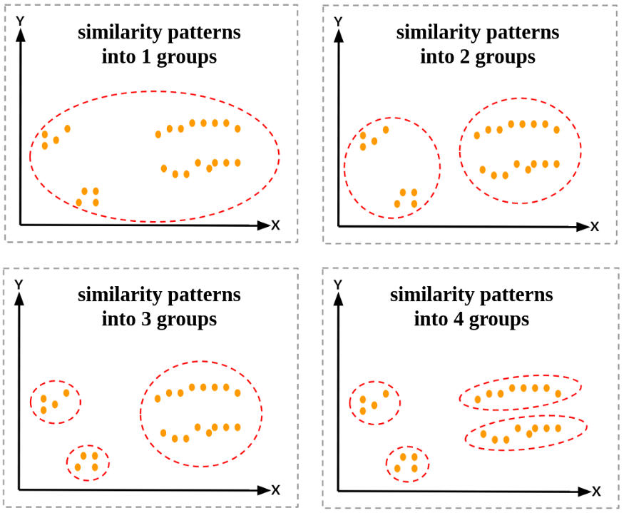

How do we know a point has the same group as another point?

***As mentioned above : based on similarity patterns***

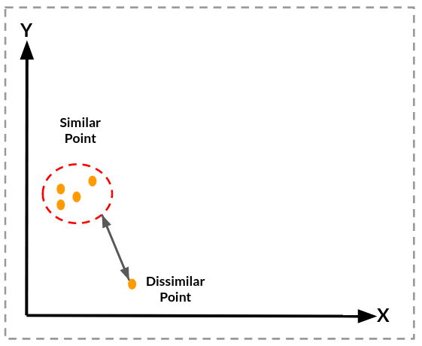

How to know the pattern similarity with K-means clustering method?

Before answering that, let’s discuss what k-means is and how k-means does clustering

THEORY — What is K-means ?

K-means clustering is a simple and elegant approach for partitioning a  
data set into K distinct, non-overlapping clusters. To perform K-means  
clustering, we must first specify the desired number of clusters K; then the  
K-means algorithm will assign each observation to exactly one of the K  
clusters [1].

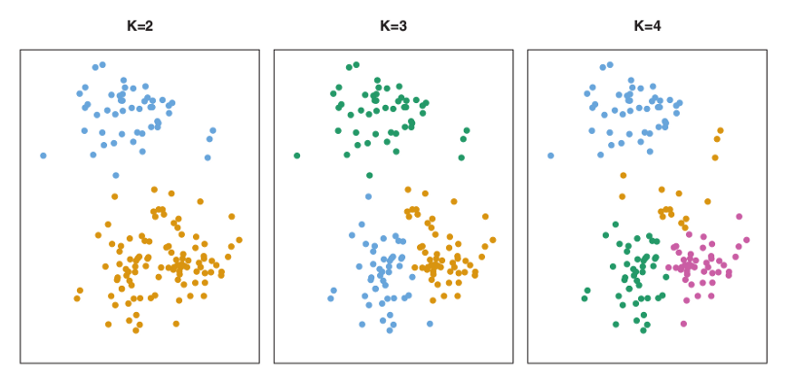

source : Intoduction to Statistical Learning with Applications in R page 387

The K-means algorithm clusters data by trying to separate samples in n groups of equal variance, minimizing a criterion known as the inertia or within-cluster sum-of-squares. The K-means algorithm aims to choose centroid that minimise the **inertia**, or **within-cluster sum-of-squares criterion**[2]:

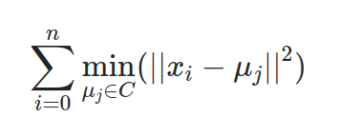

picture from [scikit-learn — clustering](https://scikit-learn.org/stable/modules/clustering.html#k-means)

How does it work?

There are several steps to explain it. For instance, there is data provided below



Here, I will explain step by step how k-means works

**Step 1. Determine the value “K”, the value “K” represents the number of clusters.**

in this case, we’ll select K=3. That is to say, we want to identify 3 clusters. **Is there any way to determine the value of K? yes there is, but we’ll talk later about it.**

Step 2. Randomly select 3 distinct centroid (new data points as cluster initialization)

**for example — attempts 1**. “K” is equal 3 so there are 3 centroid, in which case it will be the cluster initialization

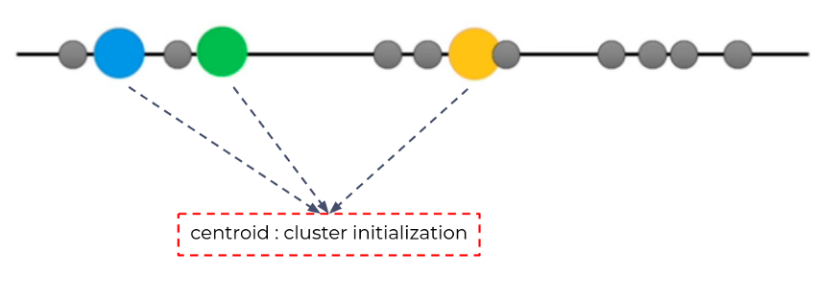

Step 3. Measure the distance ([euclidean distance](https://medium.com/@arifromadhan19/understanding-clustering-in-unsupervised-learning-b0d7a5f61f03)) between each point and the centroid

for example, measure the distance between first point and the centroid.

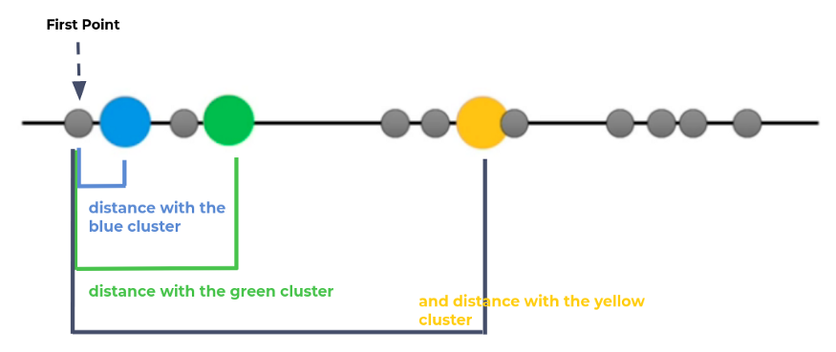

Step 4. Assign the each point to the nearest cluster

for example, measure the distance between first point and the centroid.

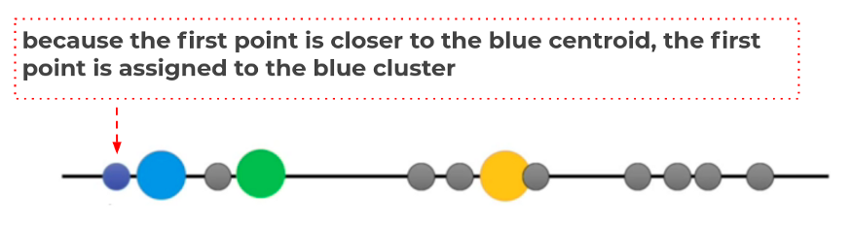

Do the same treatment for the other unlabeled point, until we get this

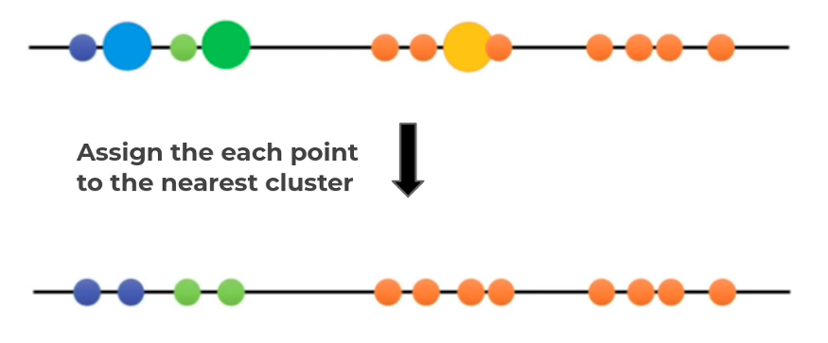

Step 5. Calculate the mean of each cluster as new centroid

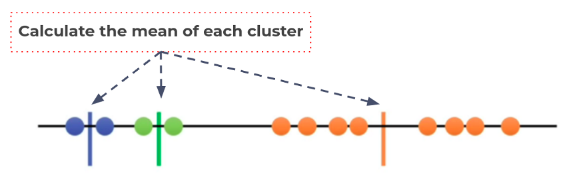

Update the centroid with mean of each cluster

Step 6. Repeat step 3–5 with the new center of cluster

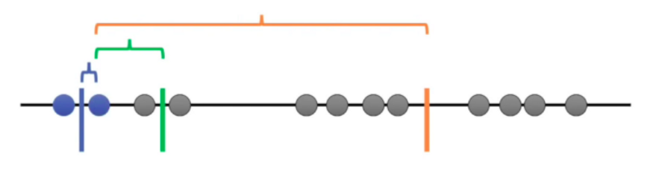

Repeat until stop:

* Convergence. (No further changes)
* Maximum number of iterations.

Since the clustering did not change at all during the last iteration, we’re done.

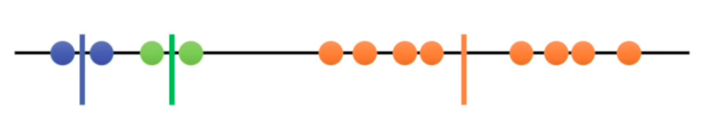

Has this process been completed? of course not

Remember, the K-means algorithm aims to choose centroid that minimise the inertia, or within-cluster sum-of-squares criterion

So, how to assess the results of this clustering? let’s continue

Step 7. Calculate the variance of each cluster



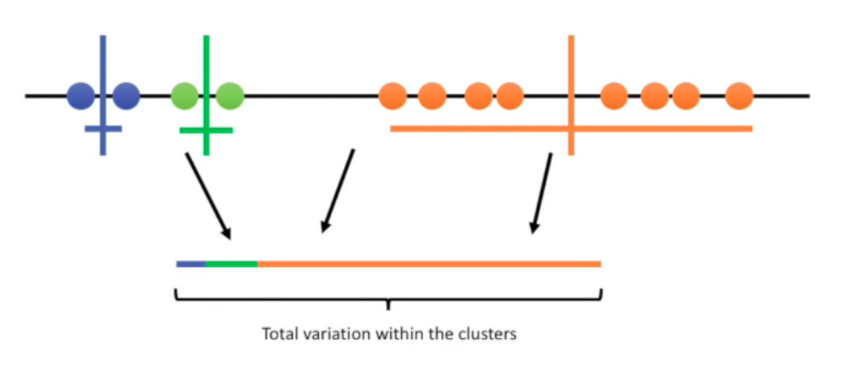

Since K-means clustering can’t “see” the best clustering, it is only option is to keep track of these clusters, and their total variance, and do the whole thing over again with different starting points.

Step 8. Repeat step 2–7 until get the lowest sum of variance

**For example — attempts 2** with different random centroid



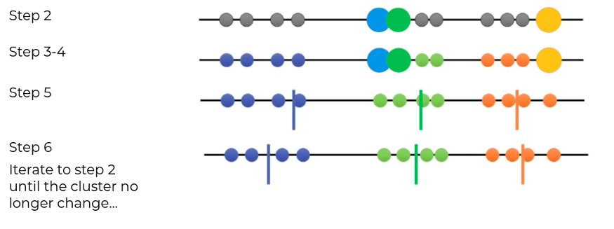



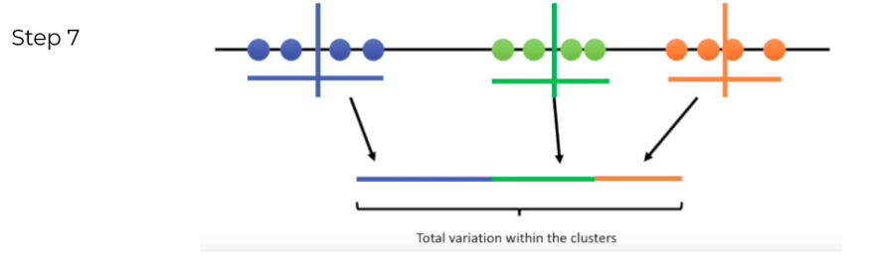

**For example — attempts 3**with different random centroid





**Repeat until stop:**

* **Until we get the lowest sum of variance and pick those cluster as our result**



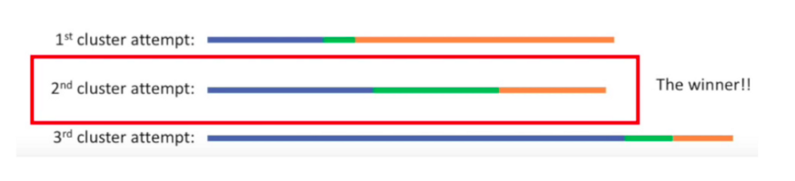

Has this process been completed? Yes

The result of clustering is



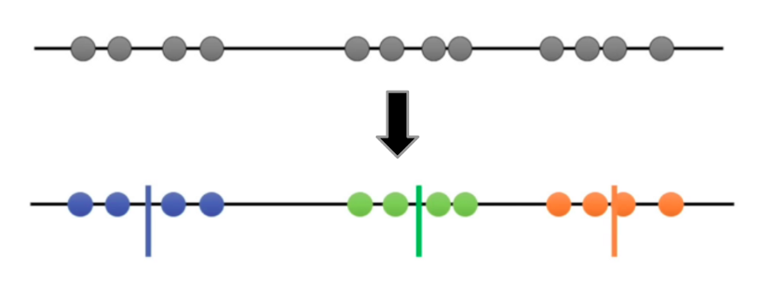

Let’s learn more about this from Coursera

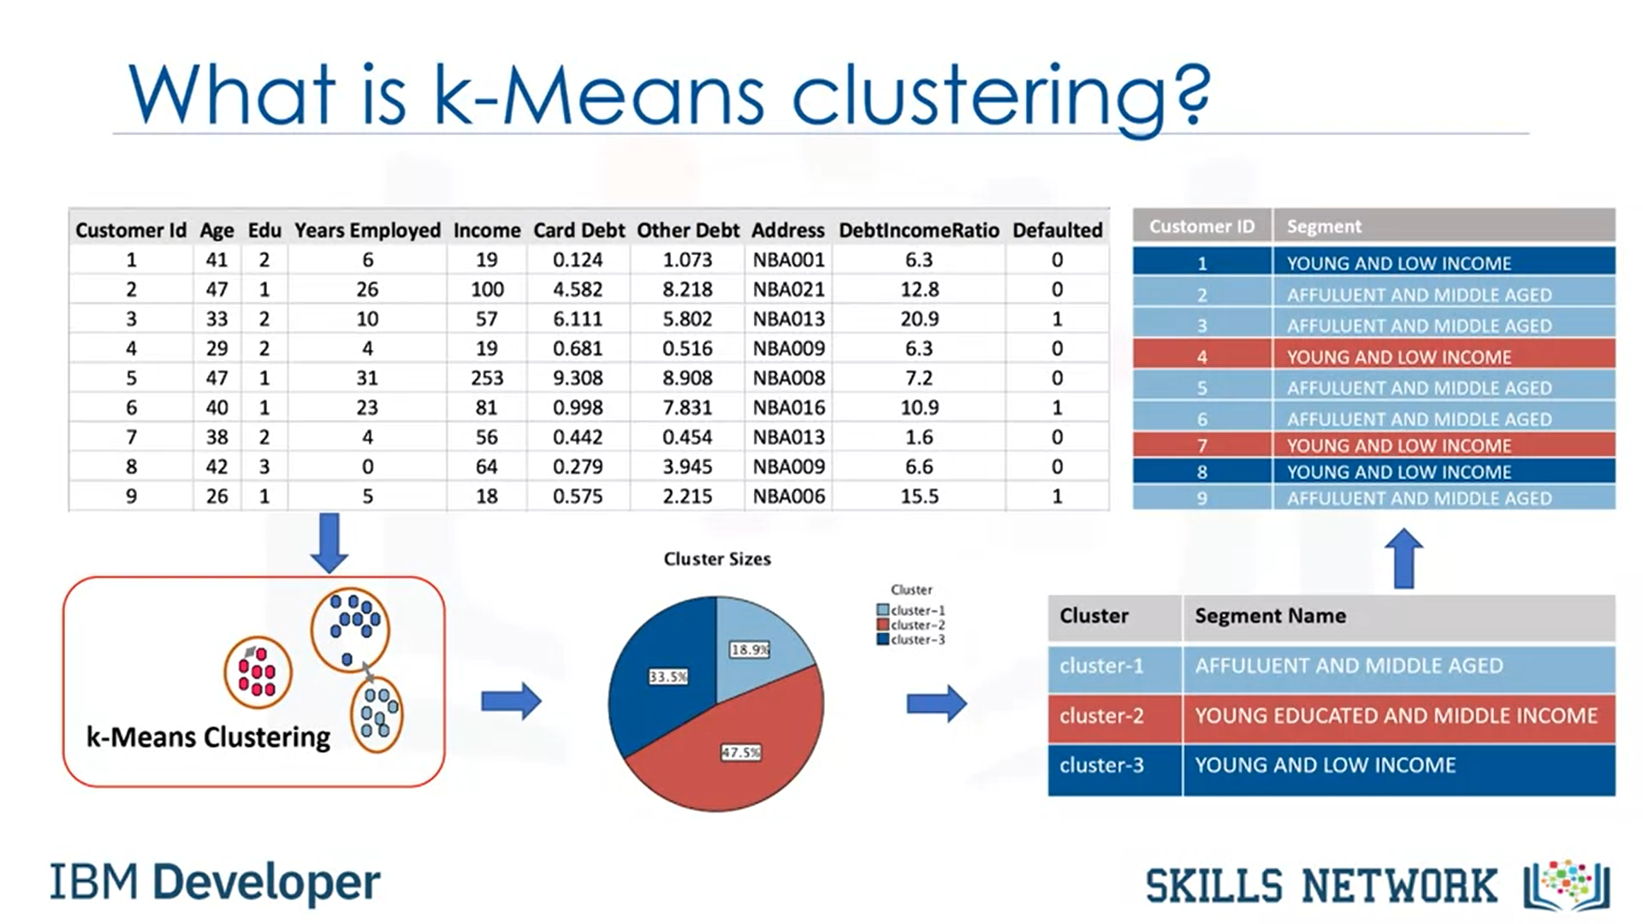

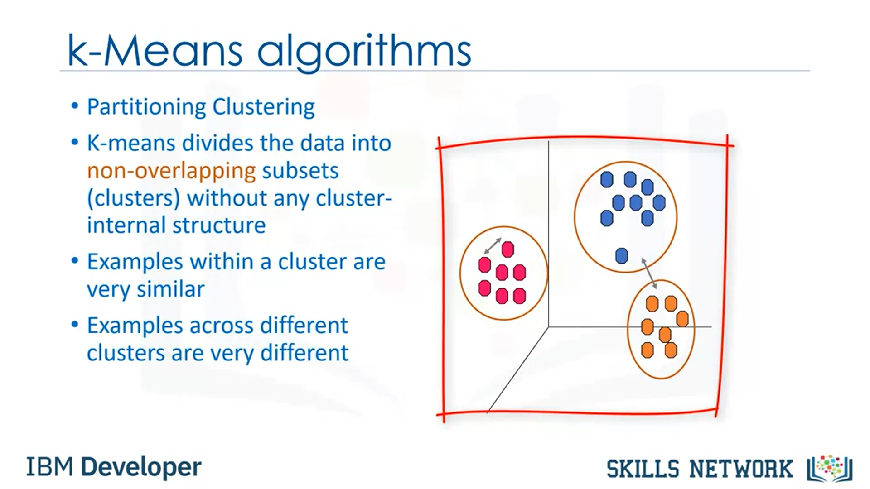

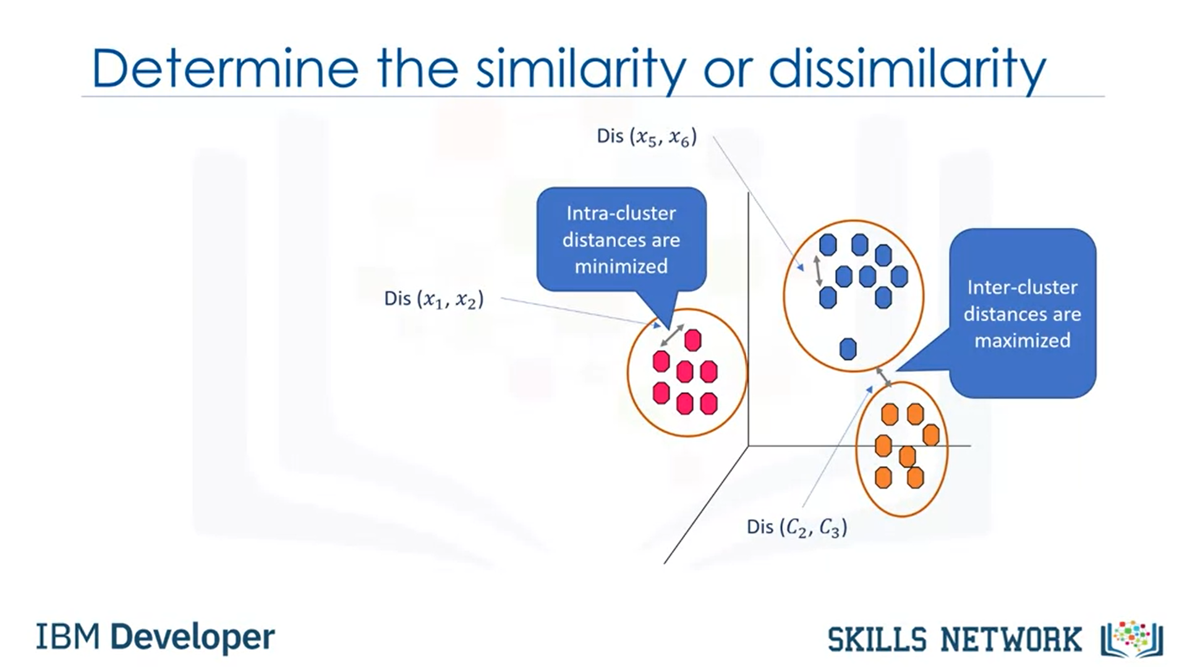

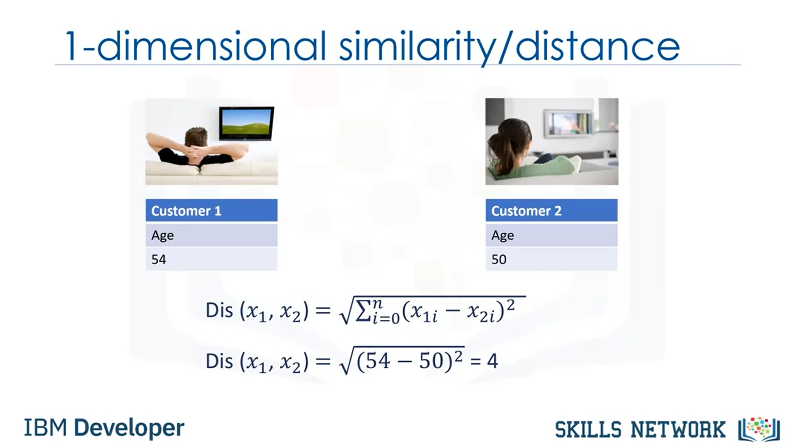

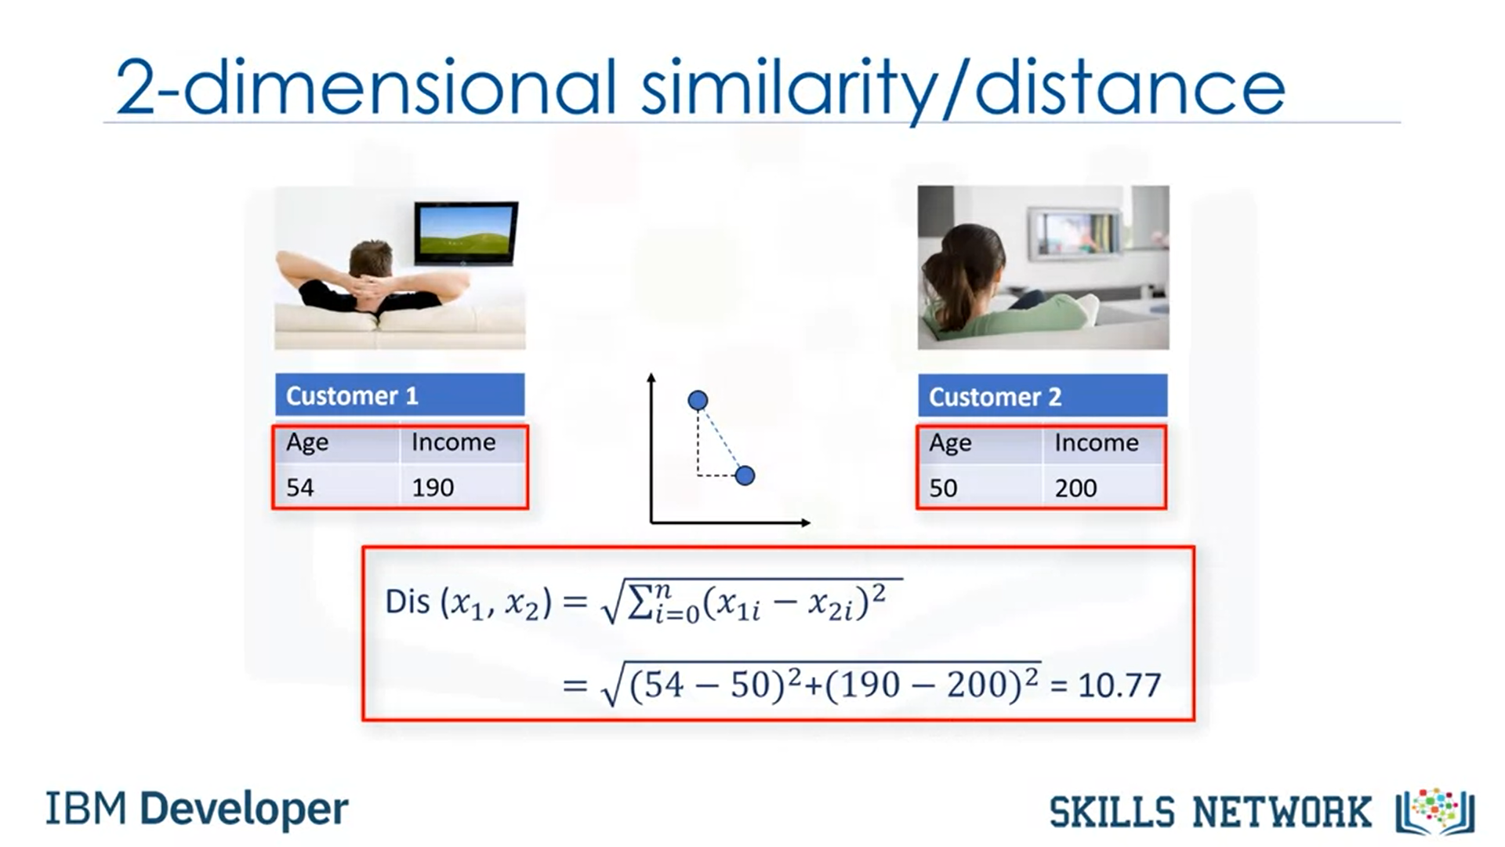

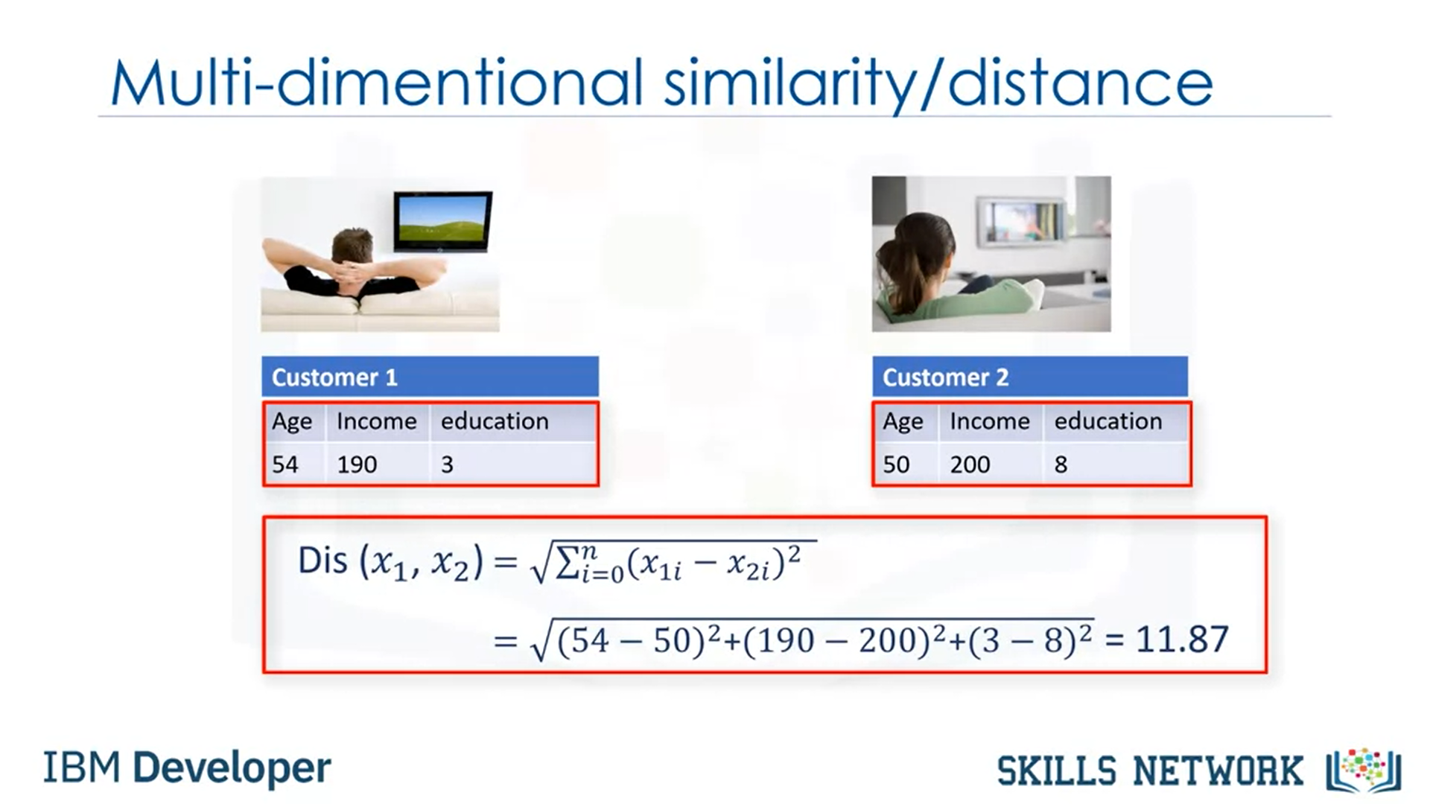

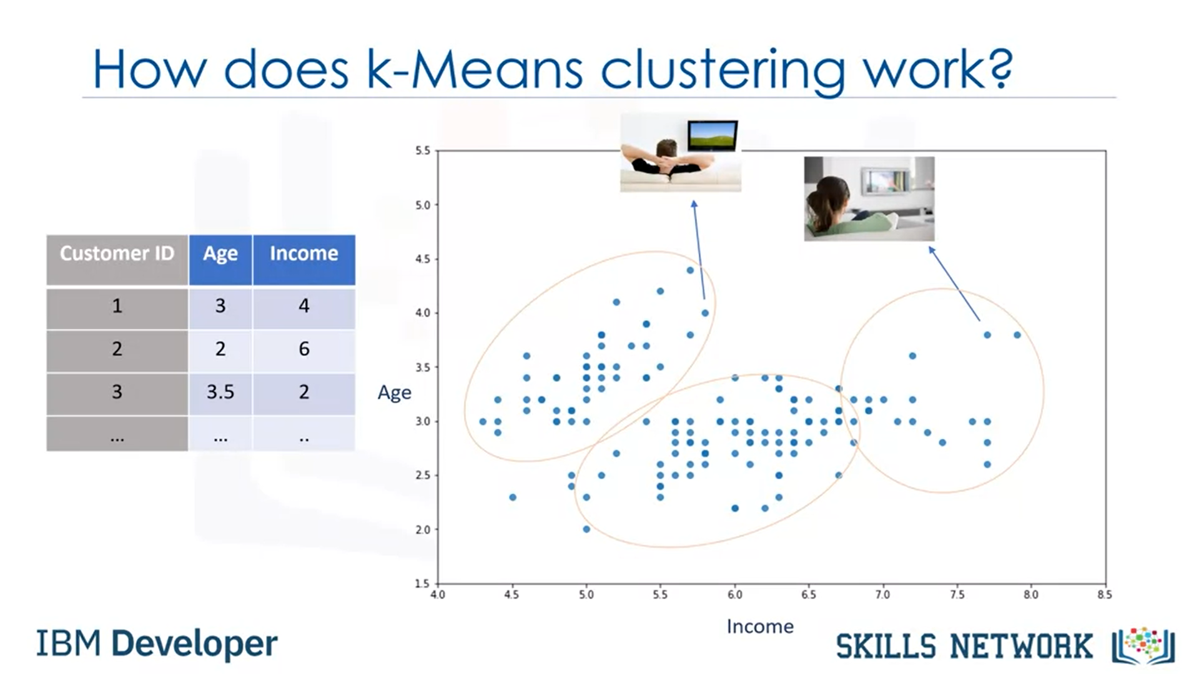

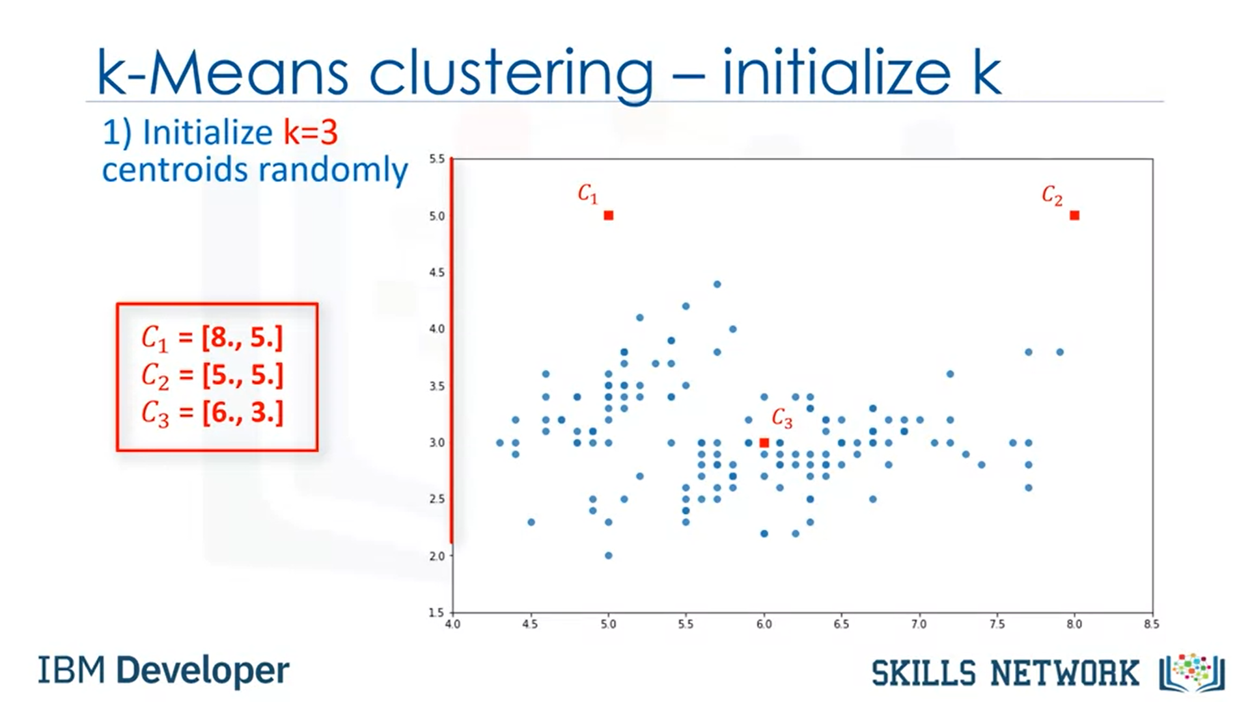

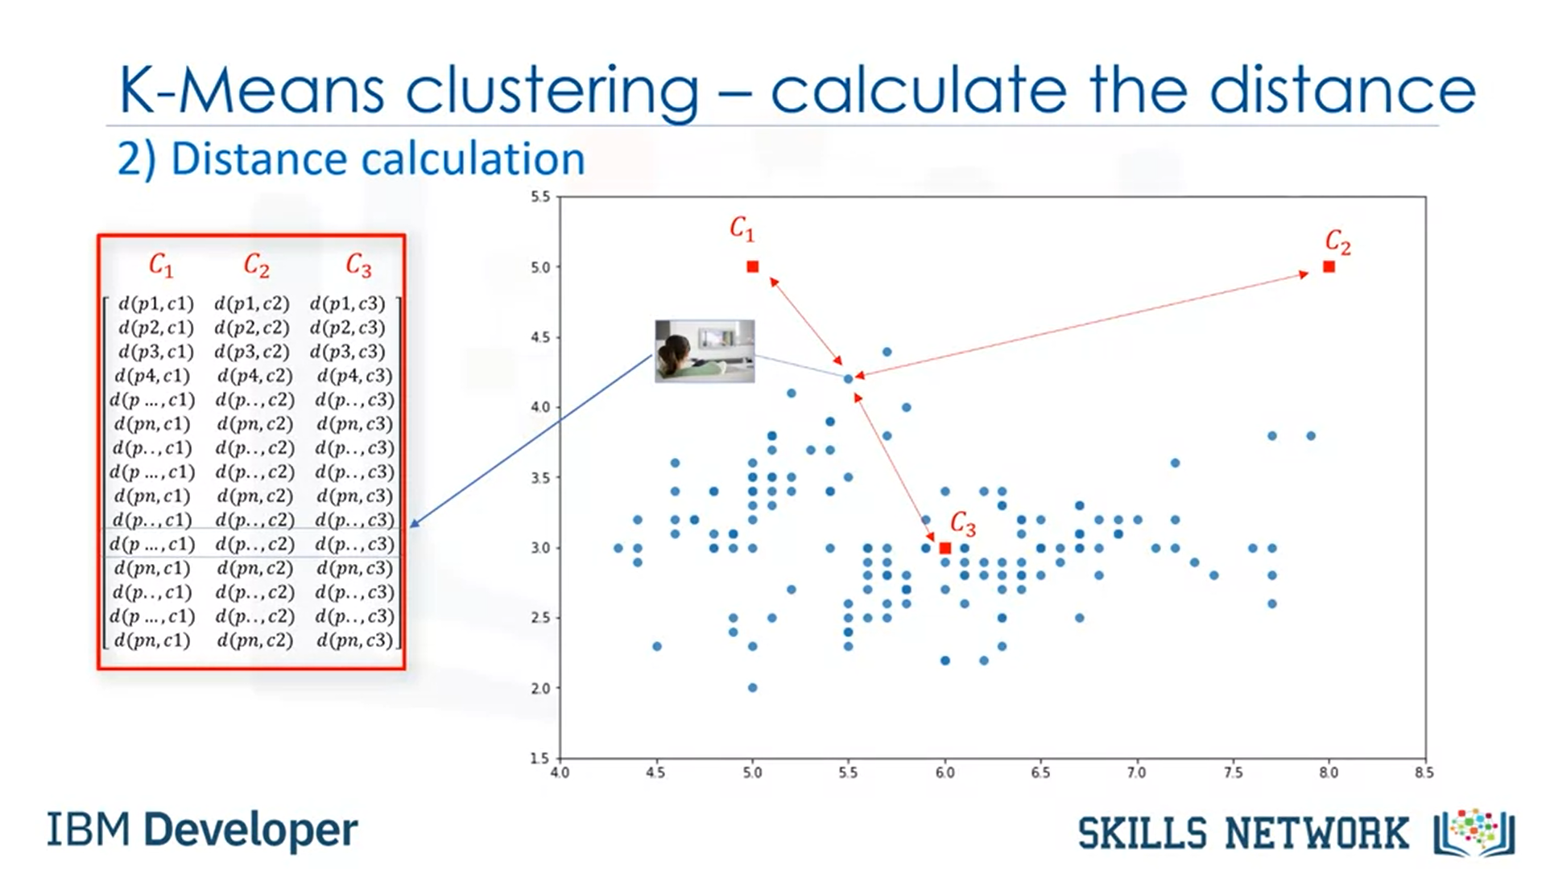

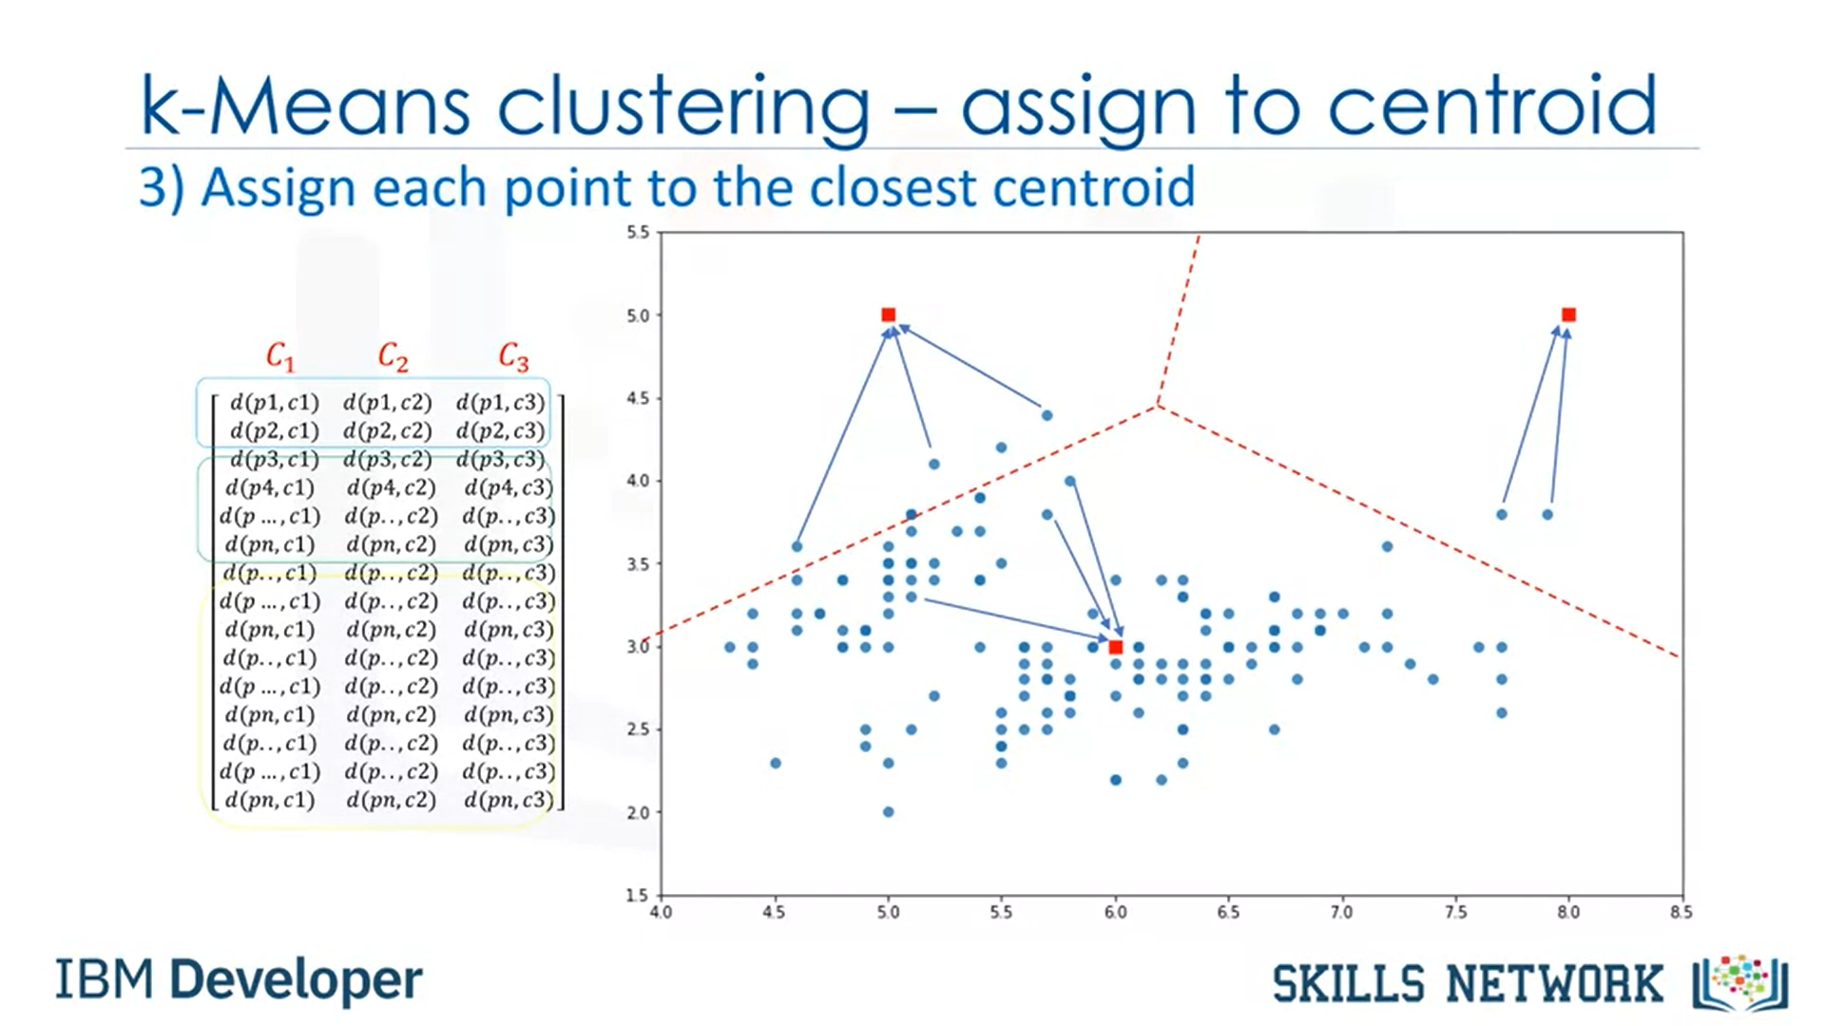

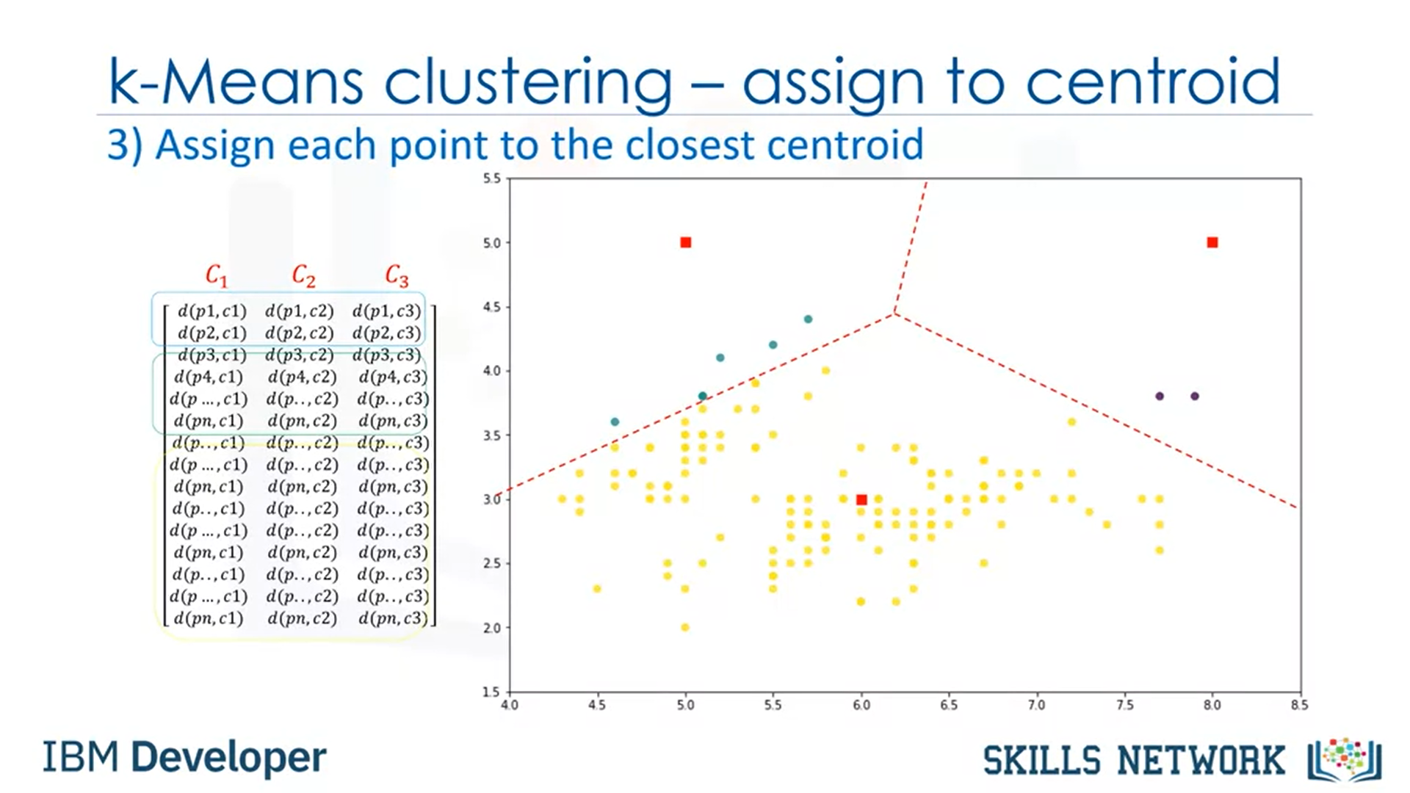

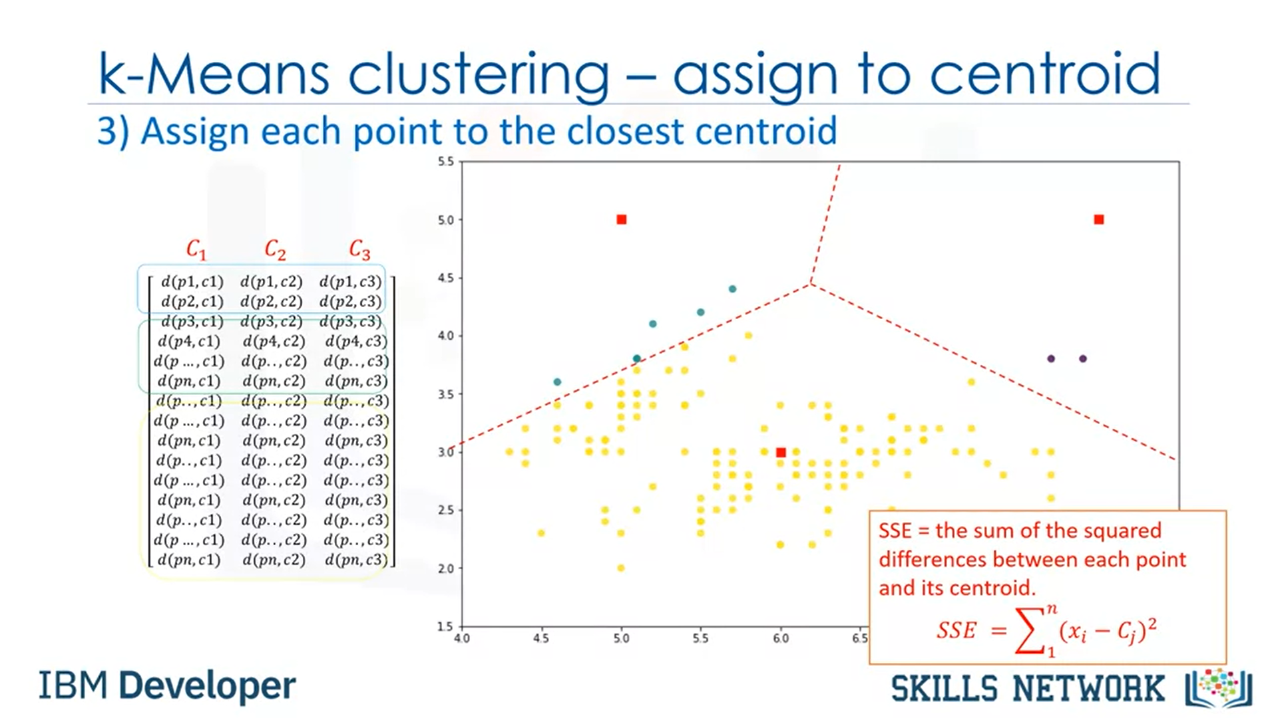

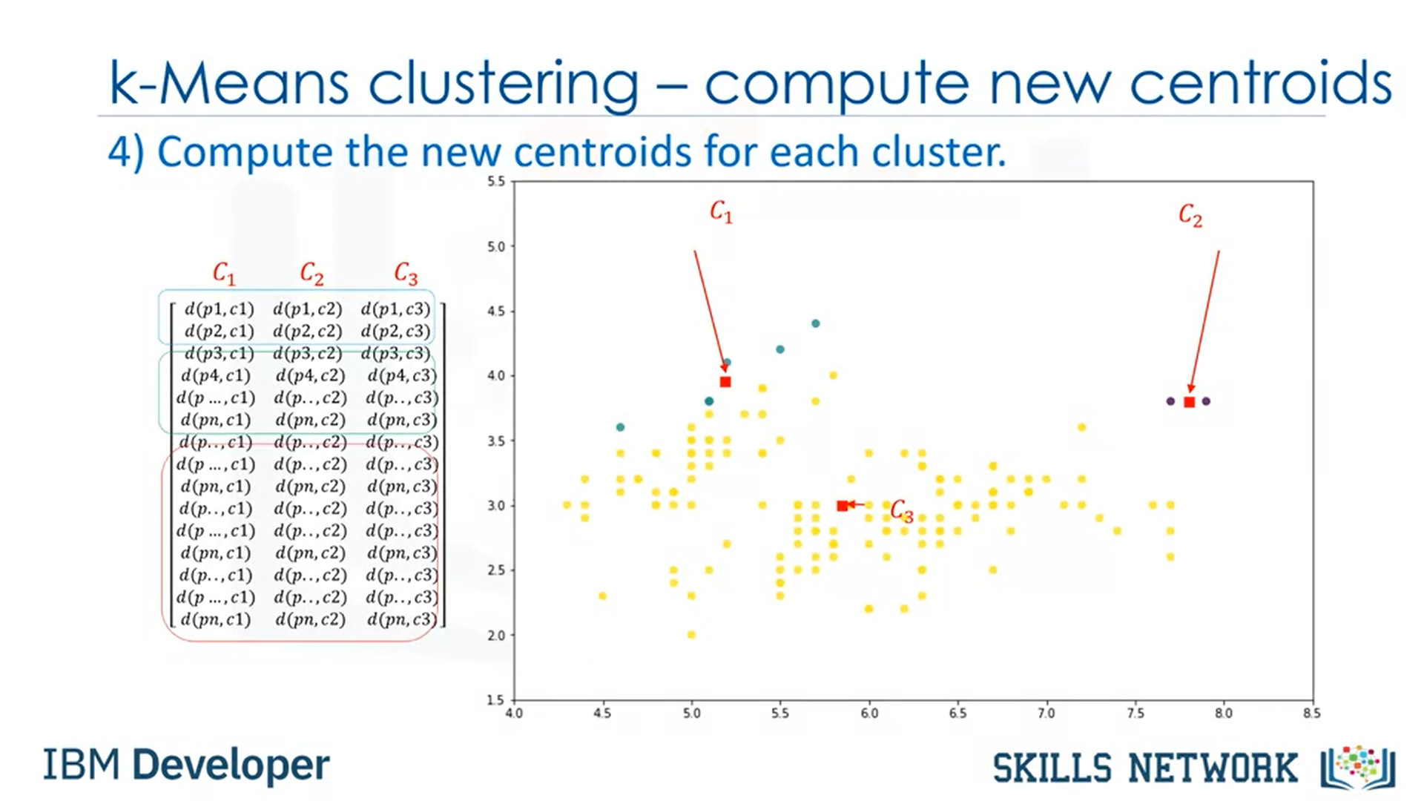

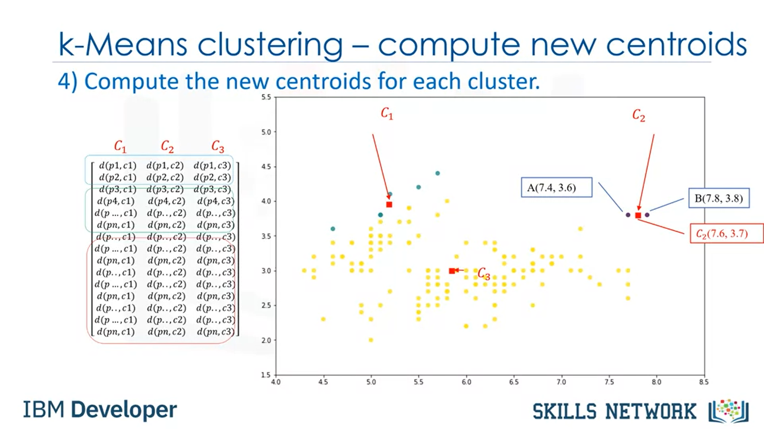

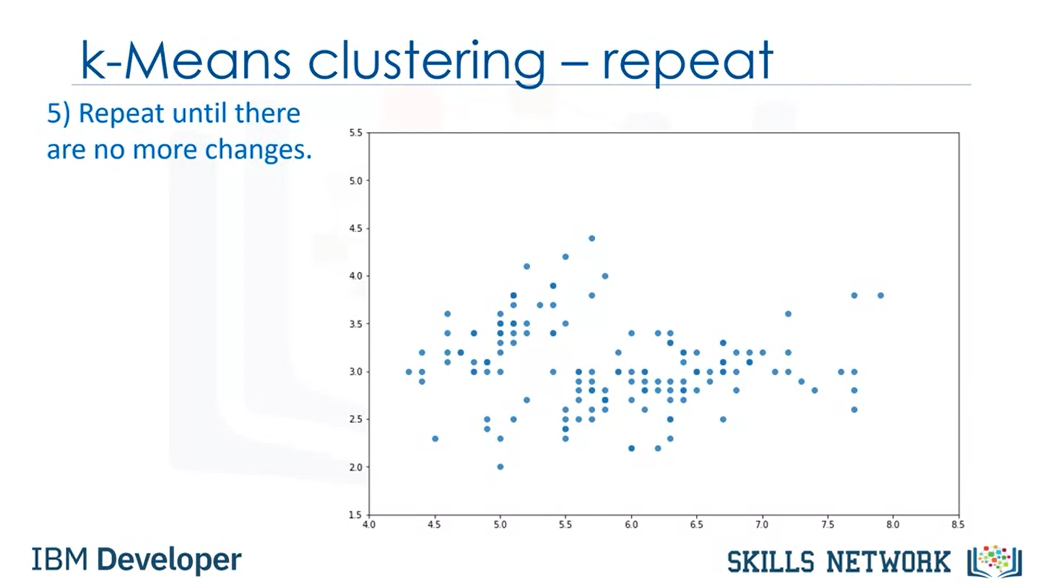

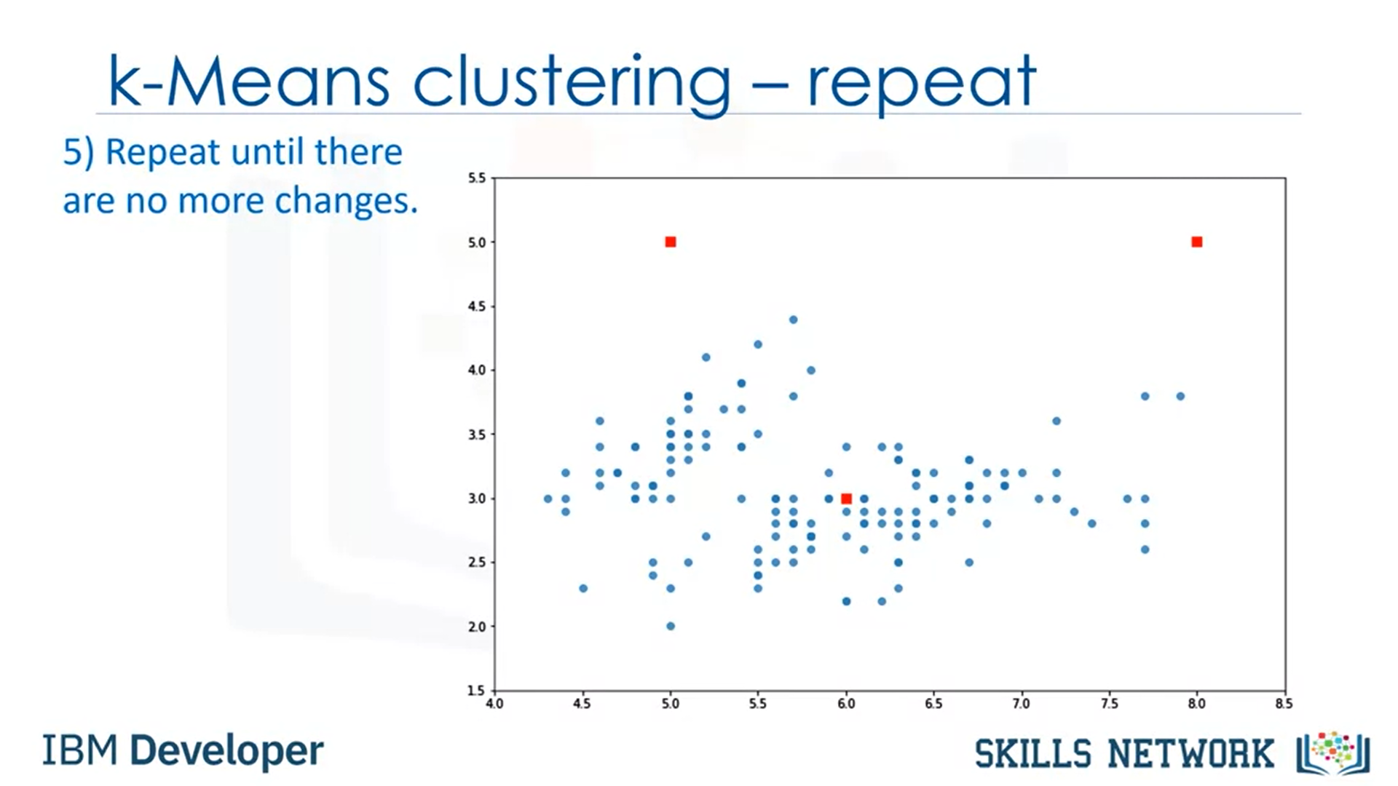

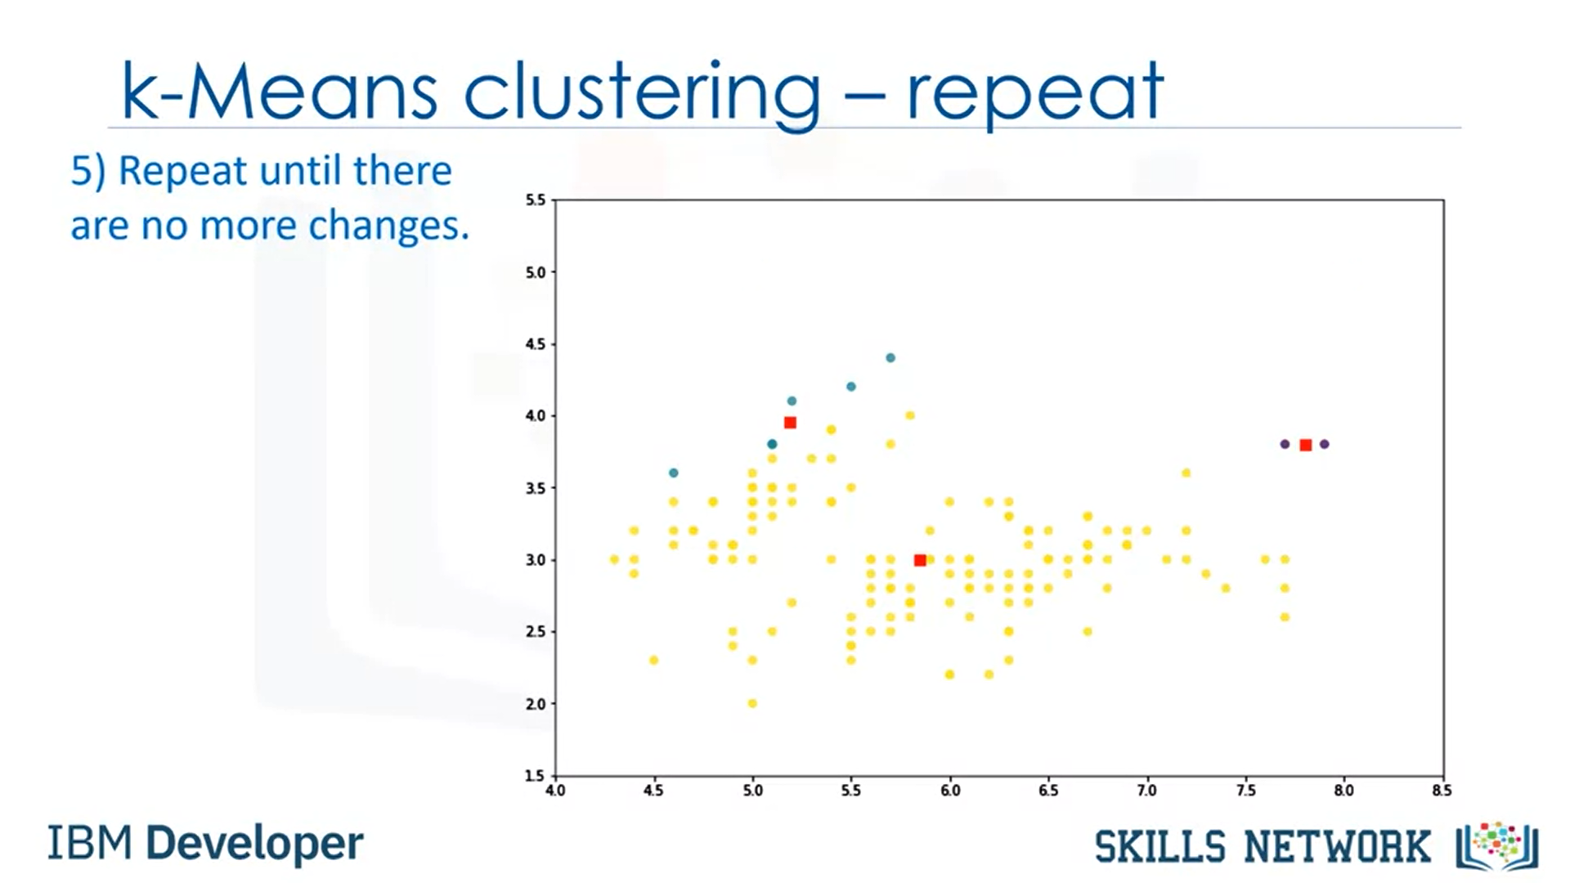

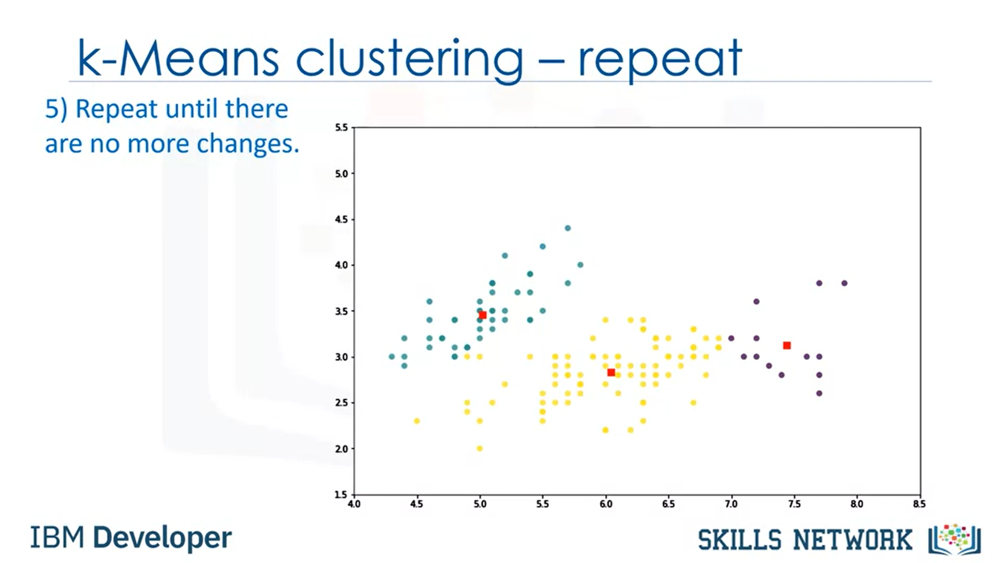

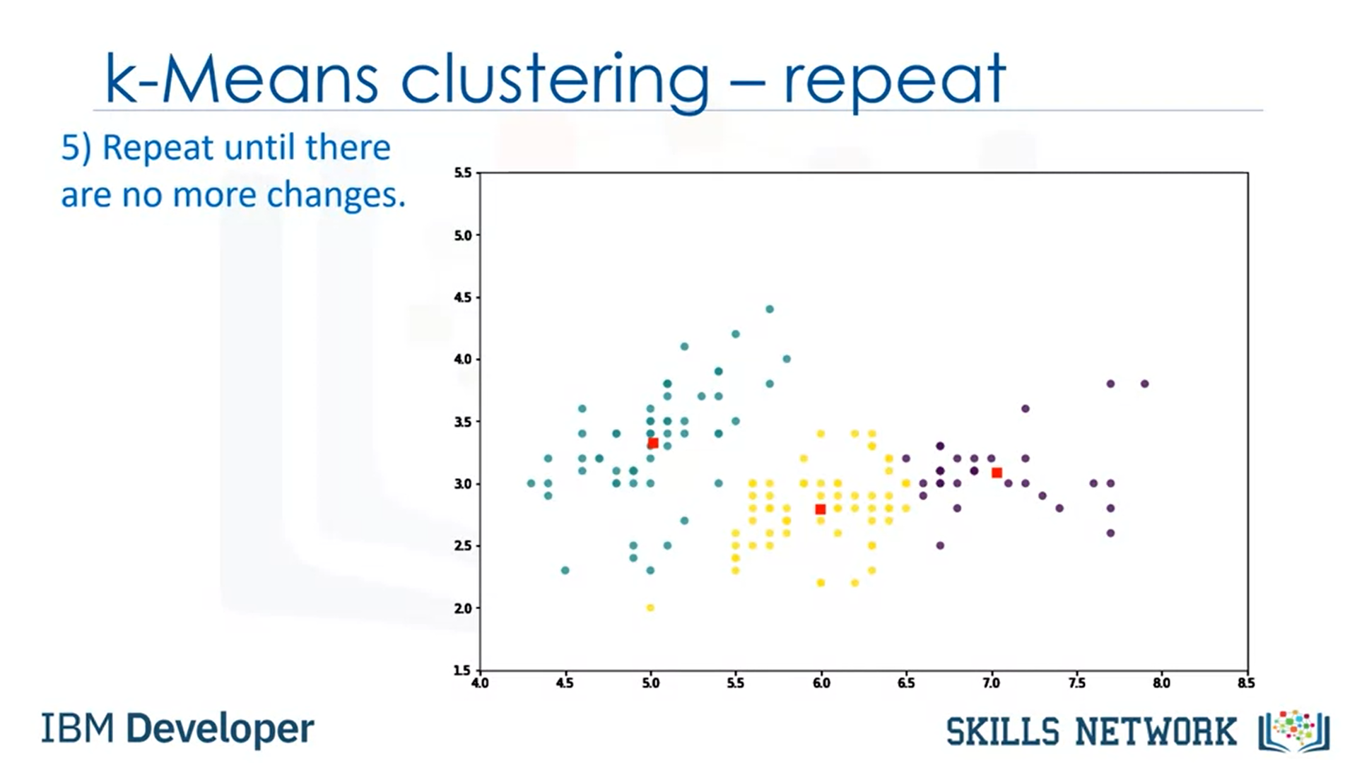

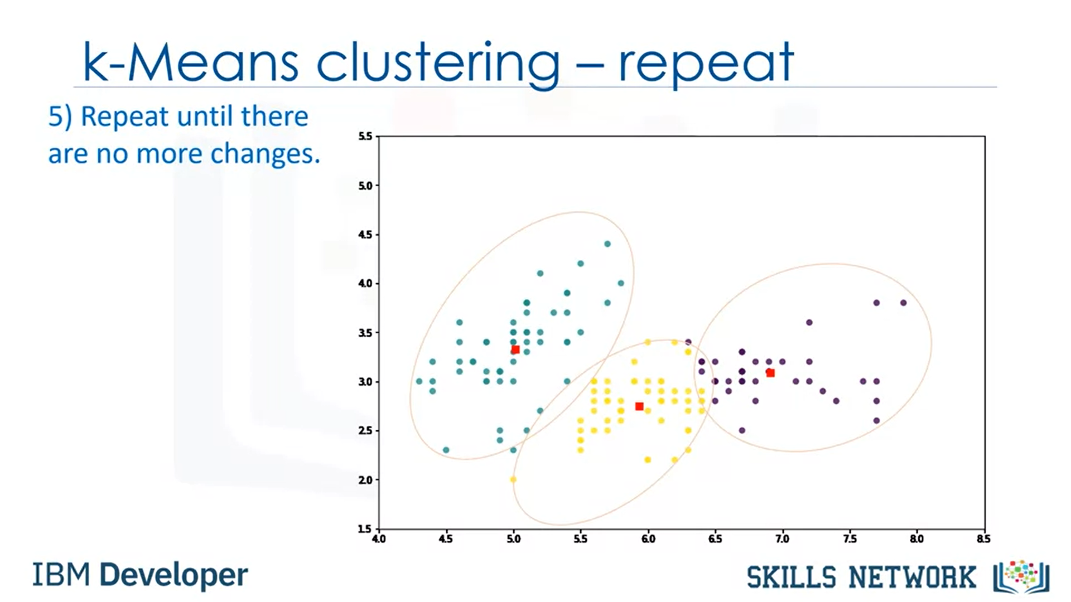

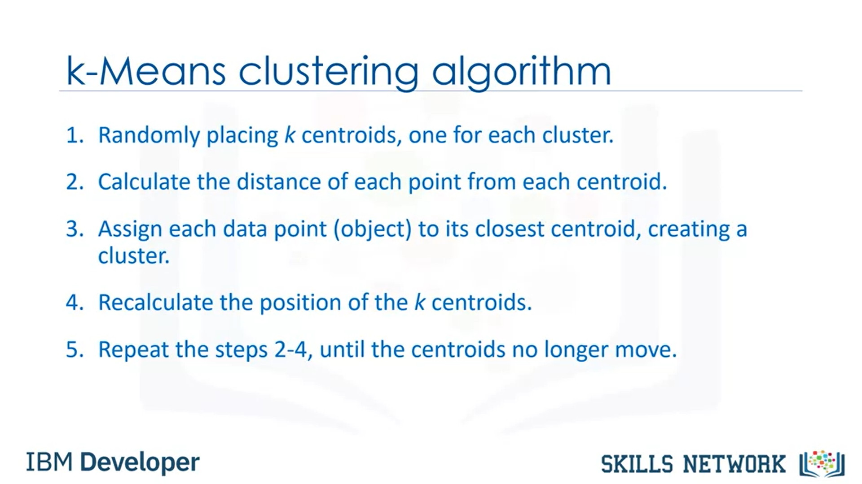’

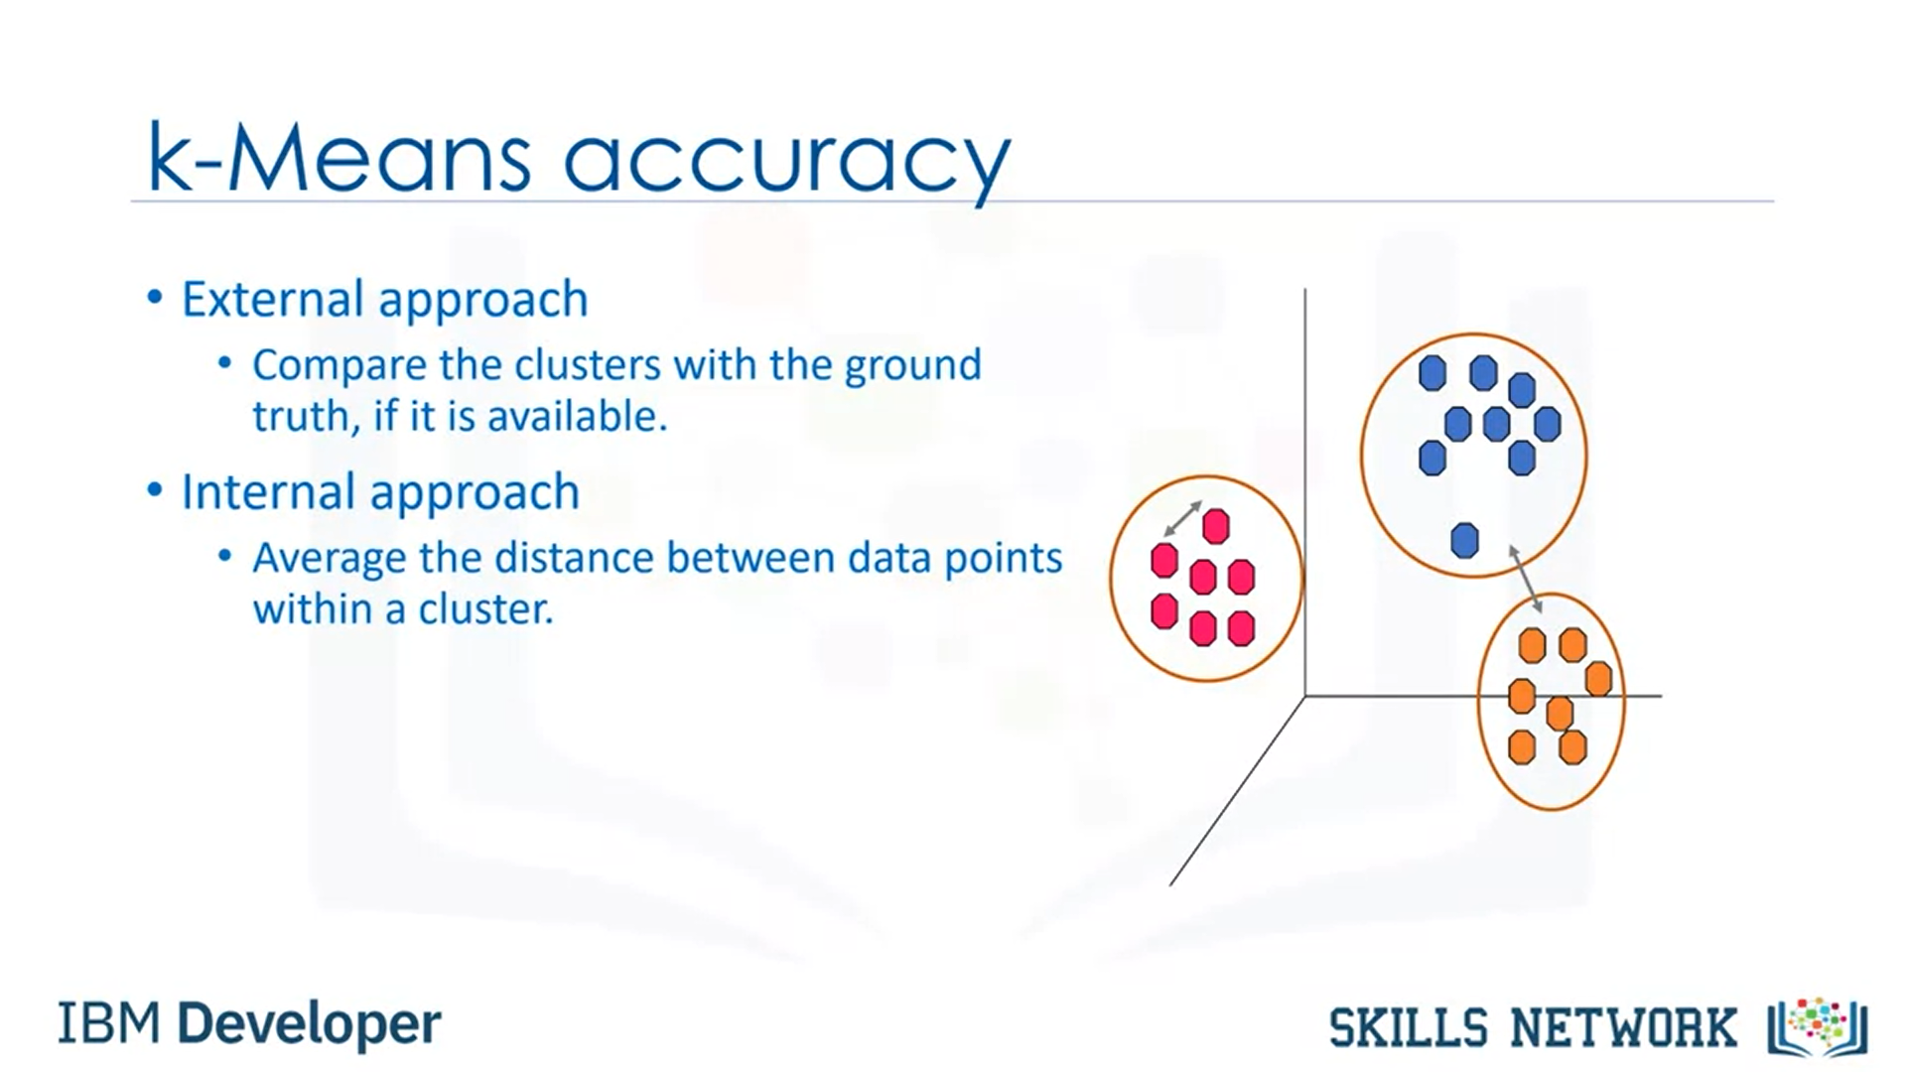

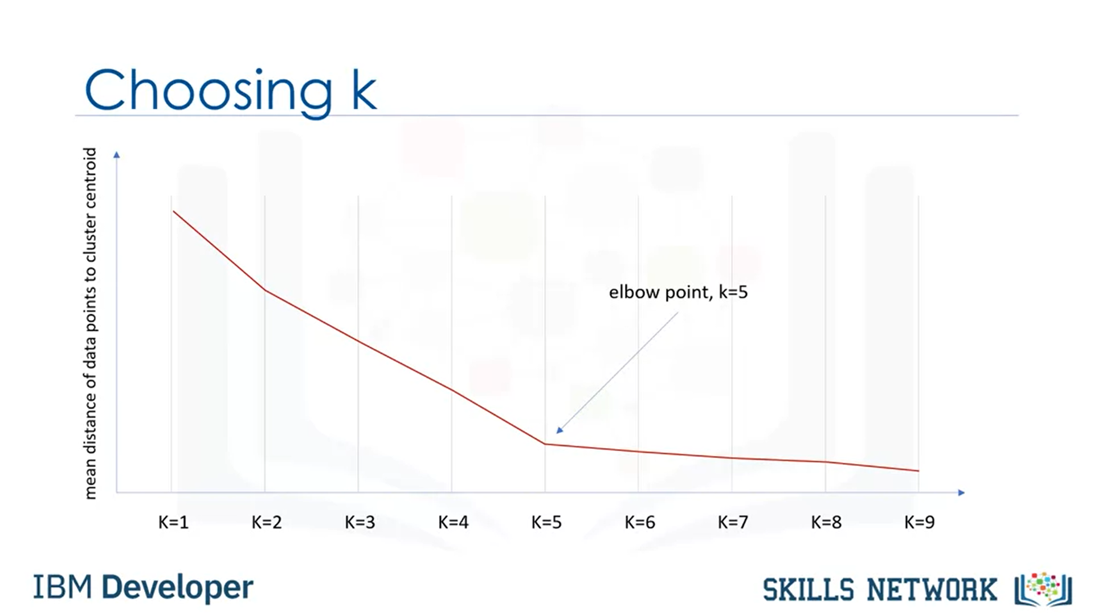

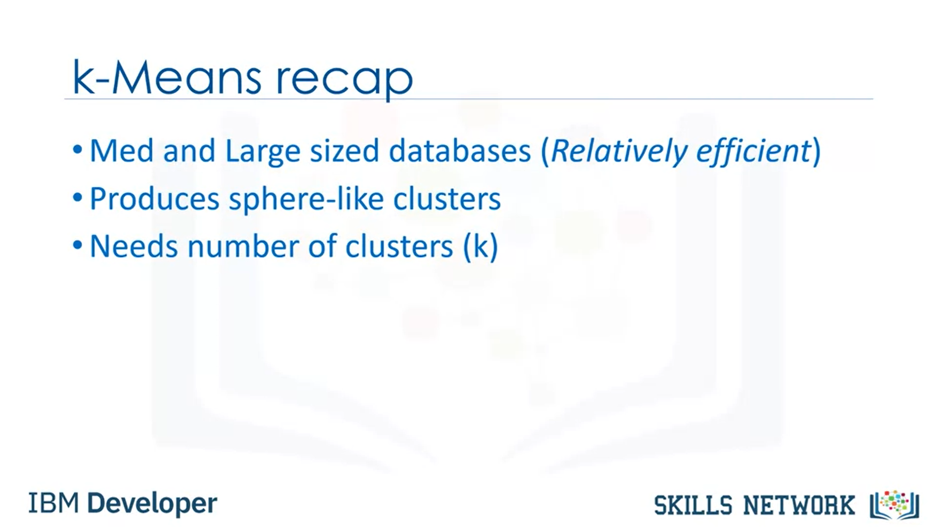

K-means Clustering Overview

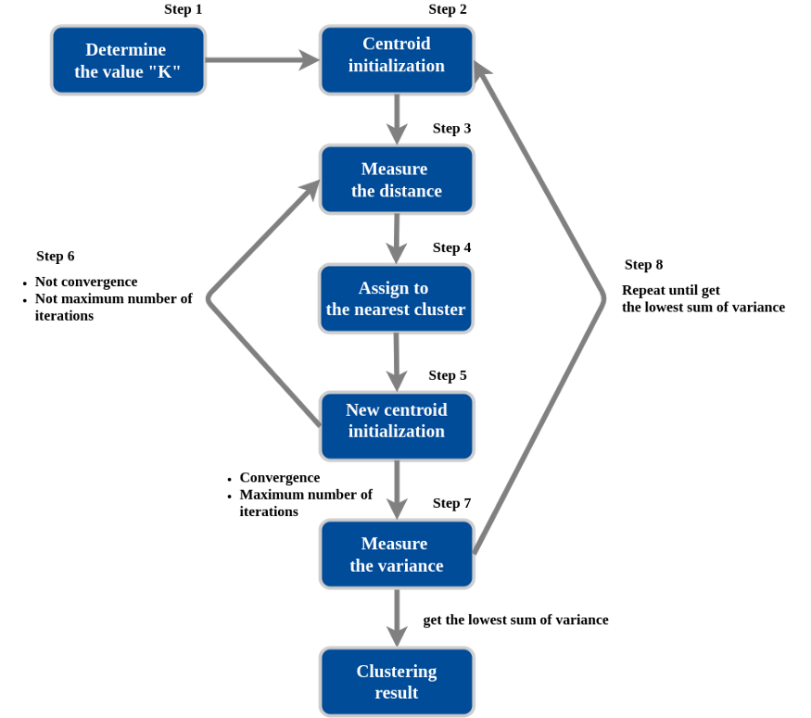

PRACTICE —How to implement K-means with sklearn in python?

The dataset is available --> [here](https://www.kaggle.com/vjchoudhary7/customer-segmentation-tutorial-in-python)

Clustering with two feature

## Import Library  
import numpy as np  
import pandas as pd  
import seaborn as sns  
import matplotlib.pyplot as plt%matplotlib inline  
from mpl_toolkits.mplot3d import Axes3Dfrom sklearn.cluster import KMeans  
from sklearn.preprocessing import StandardScaler## Load Data  
dfa = pd.read_csv("mall_customers.csv")  
dfa = dfa[['Age','Annual Income (k$)']]  
print('Total Row : ', len(dfa))## Feature Scaling  
sc_dfa = StandardScaler()  
dfa_std = sc_dfa.fit_transform(dfa.astype(float))## Clustering with KMeans  
kmeans = KMeans(n_clusters=3, random_state=42).fit(dfa_std)  
labels = kmeans.labels_new_dfa = pd.DataFrame(data = dfa_std, columns = ['Age','Annual Income (k$)'])  
new_dfa['label_kmeans'] = labelsfig, ax = plt.subplots(figsize=(10,7))  
plt.scatter(new_dfa["Annual Income (k$)"][new_dfa["label_kmeans"] == 0], new_dfa["Age"][new_dfa["label_kmeans"] == 0],   
 color = "blue", s=100, edgecolor='green',linestyle='--')plt.scatter(new_dfa["Annual Income (k$)"][new_dfa["label_kmeans"] == 1], new_dfa["Age"][new_dfa["label_kmeans"] == 1],   
 color = "red", s=100, edgecolor='green',linestyle='--')plt.scatter(new_dfa["Annual Income (k$)"][new_dfa["label_kmeans"] == 2], new_dfa["Age"][new_dfa["label_kmeans"] == 2],   
 color = "green", s=100, edgecolor='green',linestyle='--')centers = kmeans.cluster_centers_  
plt.scatter(centers[:, 0], centers[:, 1], c='black', s=500);ax.set_xlabel('Annual Income (k$)')  
ax.set_ylabel('Age')  
plt.show()

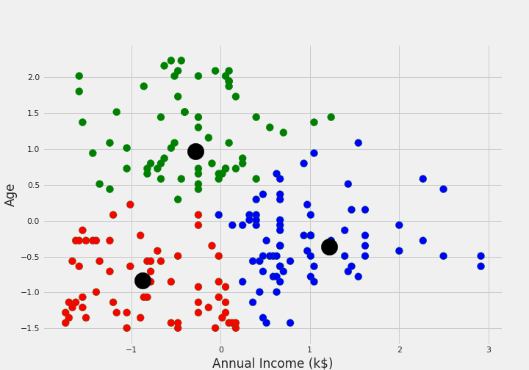

Clustering with three feature

## Load Data  
dfa = pd.read_csv(“mall_customers.csv”)  
dfa = dfa[[‘Age’,’Annual Income (k$)’,’Spending Score (1–100)’]]  
print(‘Total Row : ‘, len(dfa))## Feature Scaling  
sc_dfa = StandardScaler()  
dfa_std = sc_dfa.fit_transform(dfa.astype(float))## Clustering with KMeans  
kmeans = KMeans(n_clusters=3, random_state=42).fit(dfa_std)  
labels = kmeans.labels_new_dfa = pd.DataFrame(data = dfa_std, columns = [‘Age’,’Annual Income (k$)’,’Spending Score (1–100)’])  
new_dfa[‘label_kmeans’] = labelsfig = plt.figure(figsize=(20,10))  
ax = fig.add_subplot(111, projection=’3d’)  
ax.scatter(new_dfa.Age[new_dfa.label_kmeans == 0], new_dfa[“Annual Income (k$)”][new_dfa.label_kmeans == 0], new_dfa[“Spending Score (1–100)”][new_dfa.label_kmeans == 0], c=’blue’, s=100, edgecolor=’green’,linestyle=’ — ‘)  
ax.scatter(new_dfa.Age[new_dfa.label_kmeans == 1], new_dfa[“Annual Income (k$)”][new_dfa.label_kmeans == 1], new_dfa[“Spending Score (1–100)”][new_dfa.label_kmeans == 1], c=’red’, s=100, edgecolor=’green’,linestyle=’ — ‘)  
ax.scatter(new_dfa.Age[new_dfa.label_kmeans == 2], new_dfa[“Annual Income (k$)”][new_dfa.label_kmeans == 2], new_dfa[“Spending Score (1–100)”][new_dfa.label_kmeans == 2], c=’green’, s=100, edgecolor=’green’,linestyle=’ — ‘)  
ax.scatter(new_dfa.Age[new_dfa.label_kmeans == 3], new_dfa[“Annual Income (k$)”][new_dfa.label_kmeans == 3], new_dfa[“Spending Score (1–100)”][new_dfa.label_kmeans == 3], c=’orange’, s=100, edgecolor=’green’,linestyle=’ — ‘)  
ax.scatter(new_dfa.Age[new_dfa.label_kmeans == 4], new_dfa[“Annual Income (k$)”][new_dfa.label_kmeans == 4], new_dfa[“Spending Score (1–100)”][new_dfa.label_kmeans == 4], c=’purple’, s=100, edgecolor=’green’,linestyle=’ — ‘)centers = kmeans.cluster_centers_  
ax.scatter(centers[:, 0], centers[:, 1], centers[:, 2], c=’black’, s=500);plt.xlabel(“Age”)  
plt.ylabel(“Annual Income (k$)”)  
ax.set_zlabel(‘Spending Score (1–100)’)  
plt.show()

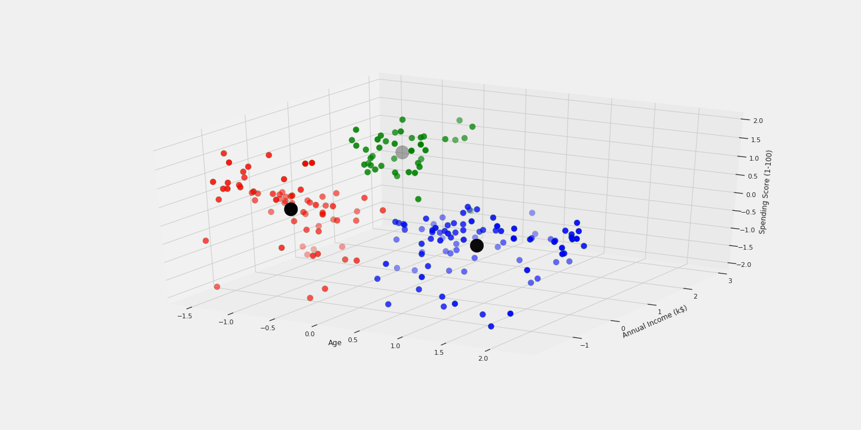

Reference

1. James. Gareth, Witten. Daniela, Hastie. Trevor, Tibshirani. Robert, Intoduction to Statistical Learning with Applications in R.
2. [scikit-learn — clustering](https://scikit-learn.org/stable/modules/clustering.html#k-means)
3. [StatQuest: K-means clustering](https://www.youtube.com/watch?v=4b5d3muPQmA&t=266s)